Figure 1. (a) 20th century simulation of globally averaged surface temperature anomalies from the NCAR CCSM3 and the GFDL CM2 and from observations. (b) Climate forcing of the 20th century from greenhouse gases (GHG), the sum of greenhouse gases and tropospheric aerosols (GHG+Aer), and total forcing from greenhouse gases, tropospheric aerosols, solar variability and volcanic forcing.

(a)
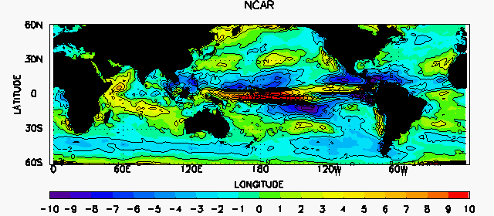
(b)
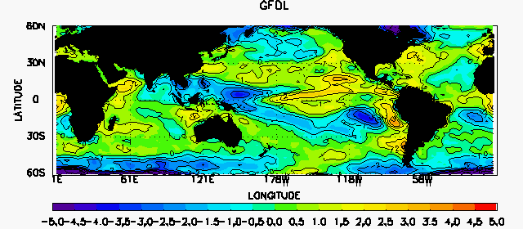

Figure 2. Change of cloud forcing in equilibrium climate change simulations normalized by a unit change of averaged surface temperature from 60ºS to 60ºN (unit in W/m²/K). (a) from the NCAR CCSM3; (b) from the GFDL CM2.

Figure 3. Schematics of the three components of the model

Figure 4. (a) Projected climate forcing for the 21st century from the IPCC A1B and B1 scenarios. (b) Idealized forcing used in this paper (solid blue).

Figure 5. Equilibrium (dashed) and transient (solid) response of surface temperature to external forcing without a deep ocean. Red and blue represent positive and negative cloud feedbacks of 0.75 W/m²/K and -0.75W/m²/K respectively; black represents zero cloud feedback. (a) The first 50 years. (b) The entire 150 years.

Figure 6. (a) Equilibrium (dashed) and transient (solid) response of surface temperature to external forcing with a deep ocean, color scheme is the same as in Figure 5. (b) Heat fluxes from the forcing (green), into the ocean (solid lines in red, black, and blue), loss through the atmosphere (dashed lines in red, black, and blue), and heat storage in the mixed layer (dotted lines). Red and blue represent positive and negative cloud feedbacks of 0.75 W/m2/K and -0.75W/m2/K respectively; black represents zero cloud feedback.

Figure 7. Heat flux into the deep ocean as a function of heat storage in the mixed layer for two cloud feedbacks.

Figure 8. Vertical distribution of temperature in the deep ocean plotted for every 20 years. Numbers denote the time of year. (a) positive cloud feedback of 0.75 W/m²/K ; (b) no cloud feedback; (c) negative cloud feedback of -0.75W/m²/K.

Figure 9. Sensitivity of transient surface temperature to model parameters. Solid lines are for parameters of the control case; dashed lines are for perturbed parameters. (a) Entrainment velocity is reduced from w_{e}=10×10⁻⁶ m/s to w_{e}=5×10⁻⁶ m/s. (b) Heat diffusivity is reduced from k=1×10⁻⁴ m/s to 0.5×10⁻⁴ m/s. (c) Upwelling velocity is increased from zero to 10 m/year. The color scheme is the same as in previous figures.

Figure 10. Solid lines are the same as in Figure 8a. Dashed lines are for reduced diffusivity in (a), and increased upwelling in (b).

